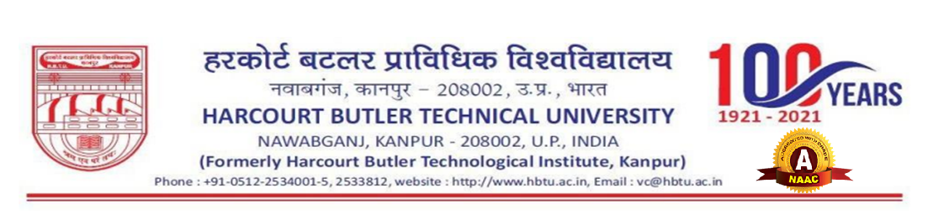

**NOTICE**

As per letter no. schedule, the competent authority has instructed to include all department of University so that maximum participation will be achieve in the competition and visit organized on 25th and 26th November, 2024, therefore it is requested to all HOD’s to kindly send 2 to 3 names of students in each event which include historic visit, speech competition, painting competition and rangoli making competition. These events are proposed by Raj Bhawan.

For the smooth conduction of the competition please send the names latest by 23/11/2024 4:30 P.M.

(Unnayan Srivastava) (Dr Anjali Awasthi)

Student Secretary, Hobby Sub - Council Convenor, Hobby Sub - Council

U.S.A.C. U.S.A.C.

H.B.T.U, KANPUR H.B.T. U, KANPUR

Copy to:

Dean Students Welfare